
Symbiosis Institute of Technology, Pune
Faculty of Engineering
CSE- Academic Year 2026-27
Java Programming – Lab Batch 2024-28
Lab Assignment No: - 28
Name of Student: Sanika Botre
PRN No.: 25070122063
Batch: 2025-29
Class: CSE A-2
Academic Year & Semester: 2026 & 3rd Semester
Date of Submission
Title of Assignment: Develop a Java application demonstrating Remote Method Invocation (RMI) using stub and skeleton components for remote communication.
Learning Objectives: To implement Remote Method Invocation for distributed Java applications.
Theory:
Remote Method Invocation (RMI) is a Java technology that enables an object running on one Java Virtual Machine (JVM) to invoke methods of an object running on another JVM located on a different machine. RMI simplifies distributed application development by allowing remote objects to behave like local objects. It consists of remote interfaces, remote object implementations, the RMI registry, and client-server communication. The registry maintains references to remote objects, allowing clients to locate and invoke them. RMI provides platform-independent communication, object serialization, and automatic network handling, making it suitable for distributed enterprise applications.

Practice questions
1. Create a remote calculator service using Java RMI
Code:

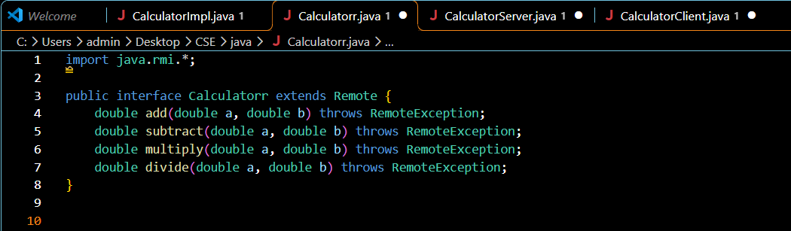
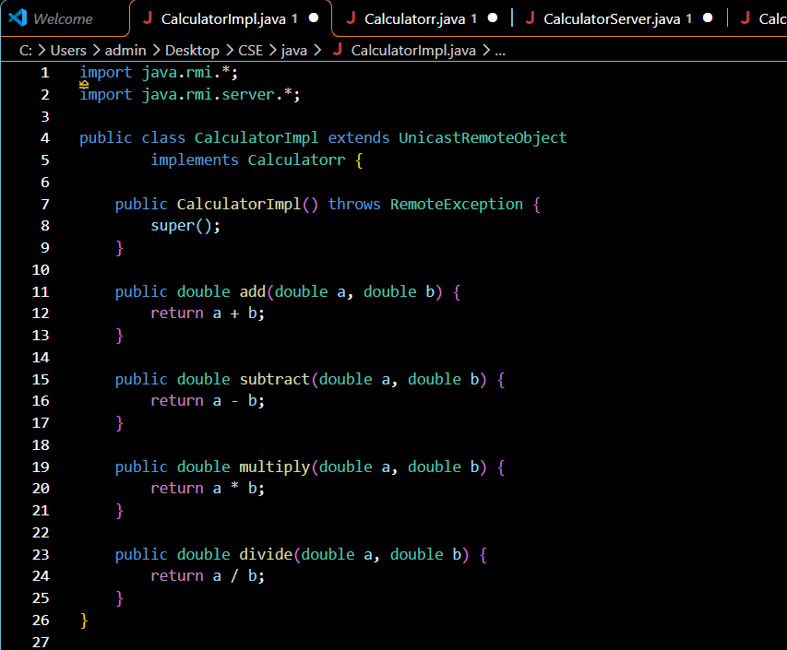
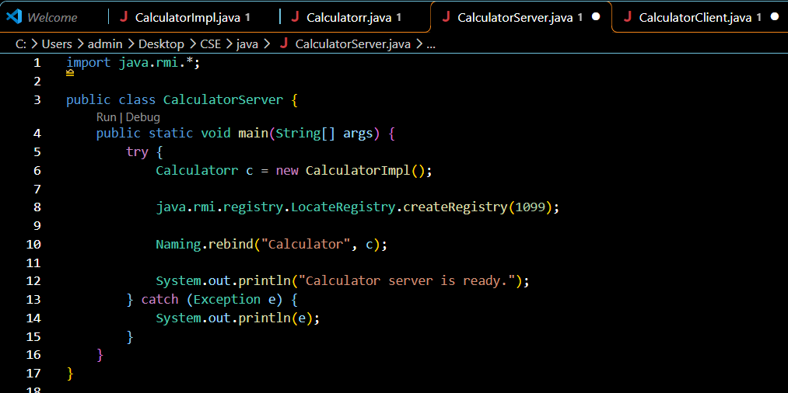
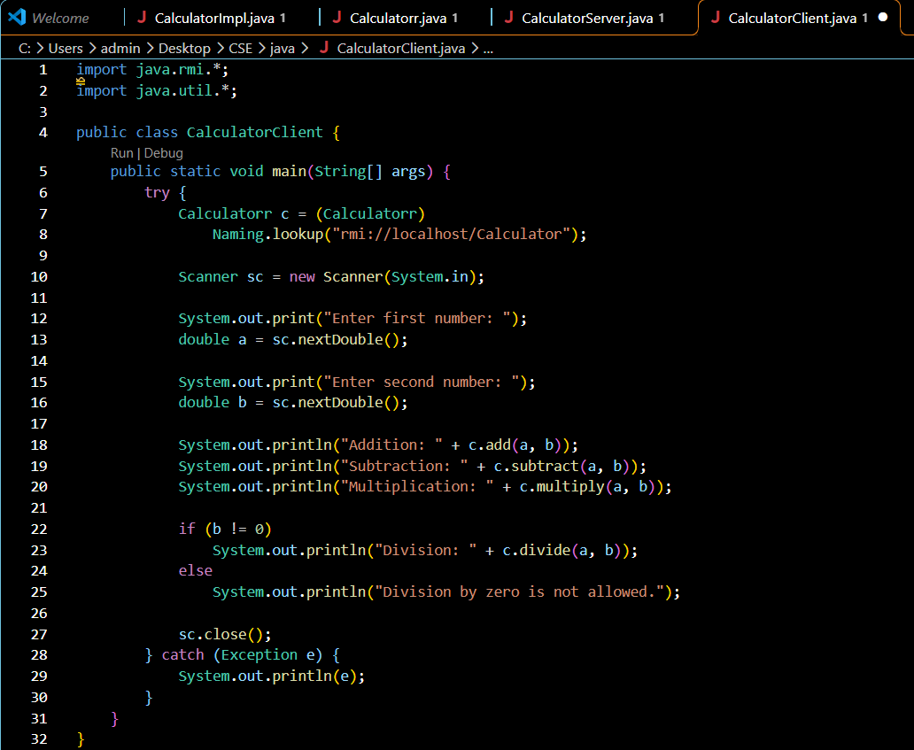
Output:
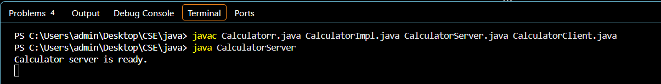
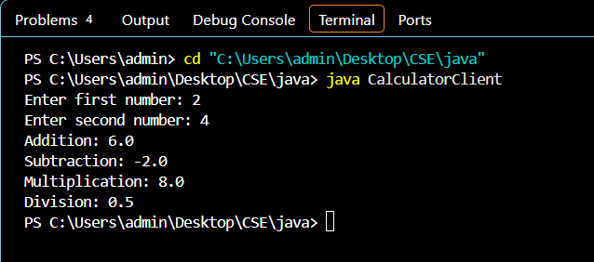

2. Create a Java application using RMI where the server converts temperature values between Celsius and Fahrenheit. The client sends input temperature and receives converted output.
Code: 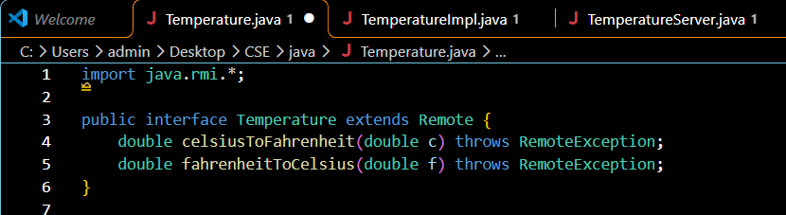
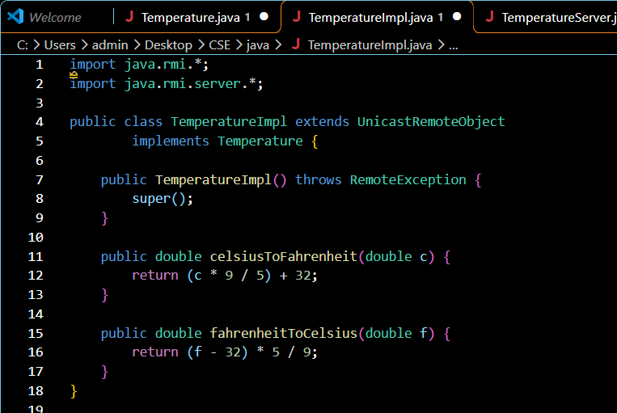
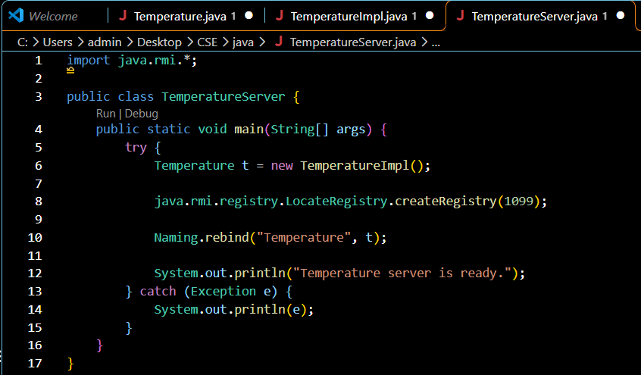
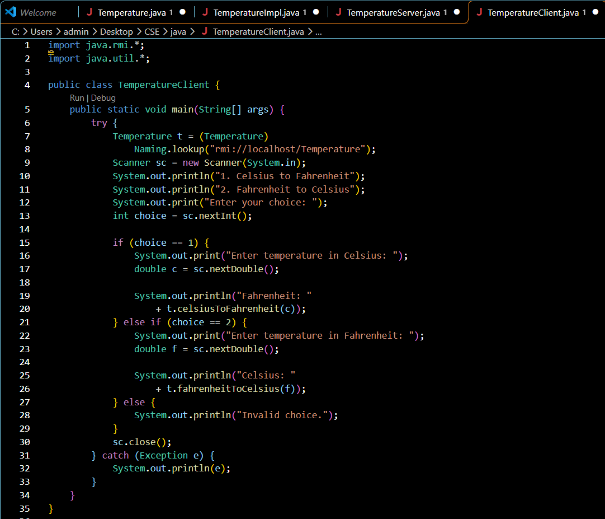

Output:
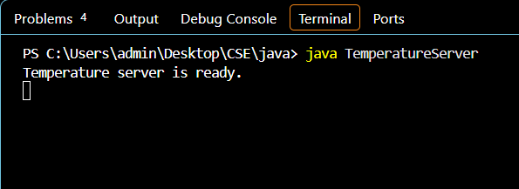
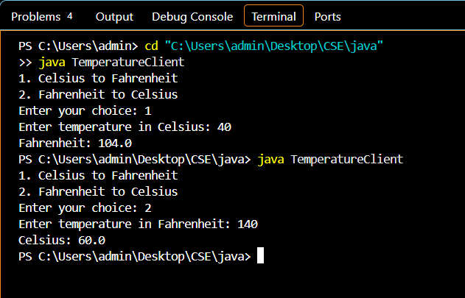

Conclusion
Thus, both programs were successfully implemented using Java RMI. The calculator service performs arithmetic operations remotely, while the temperature conversion service converts Celsius to Fahrenheit and Fahrenheit to Celsius. This assignment helped in understanding remote interfaces, remote objects, RMI Registry, and communication between Java clients and servers.

